GREAT WAKERING PARISH COUNCIL

PARISHIONER OF GREAT WAKERING AND OVER 80?

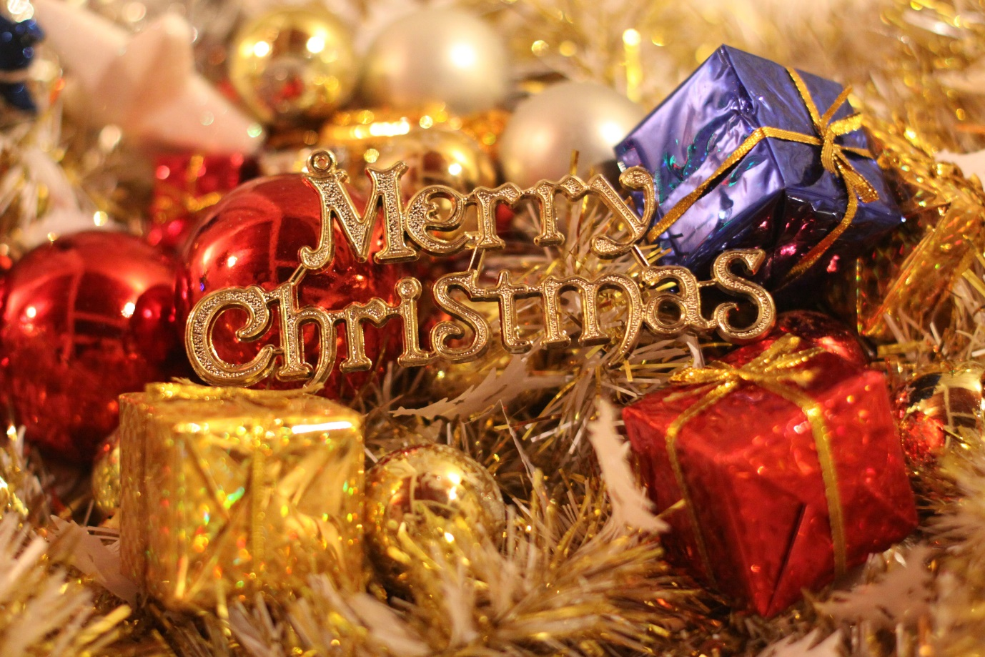

WOULD YOU LIKE TO APPLY FOR THE CHANCE TO RECEIVE A FREE CHRISTMAS FOOD PARCEL

Information and consent forms are available on our website [www.greatwakering-pc.gov.uk](http://www.greatwakering-pc.gov.uk) or from the Parish Council Office.

Closes noon 10th December